ПУБЛИКУВАН Е ПЪРВИЯТ БЪЛГАРСКИ УЧЕБНИК НА АНГЛИЙСКИ ПО КЛЕТЪЧНА БИОЛОГИЯ ЗА СТУДЕНТИ ПО МЕДИЦИНА, ДЕНТАЛНА МЕДИЦИНА И БИОЛОГИЯ. Както и за всички любознателни в биомедицинската наука и практика

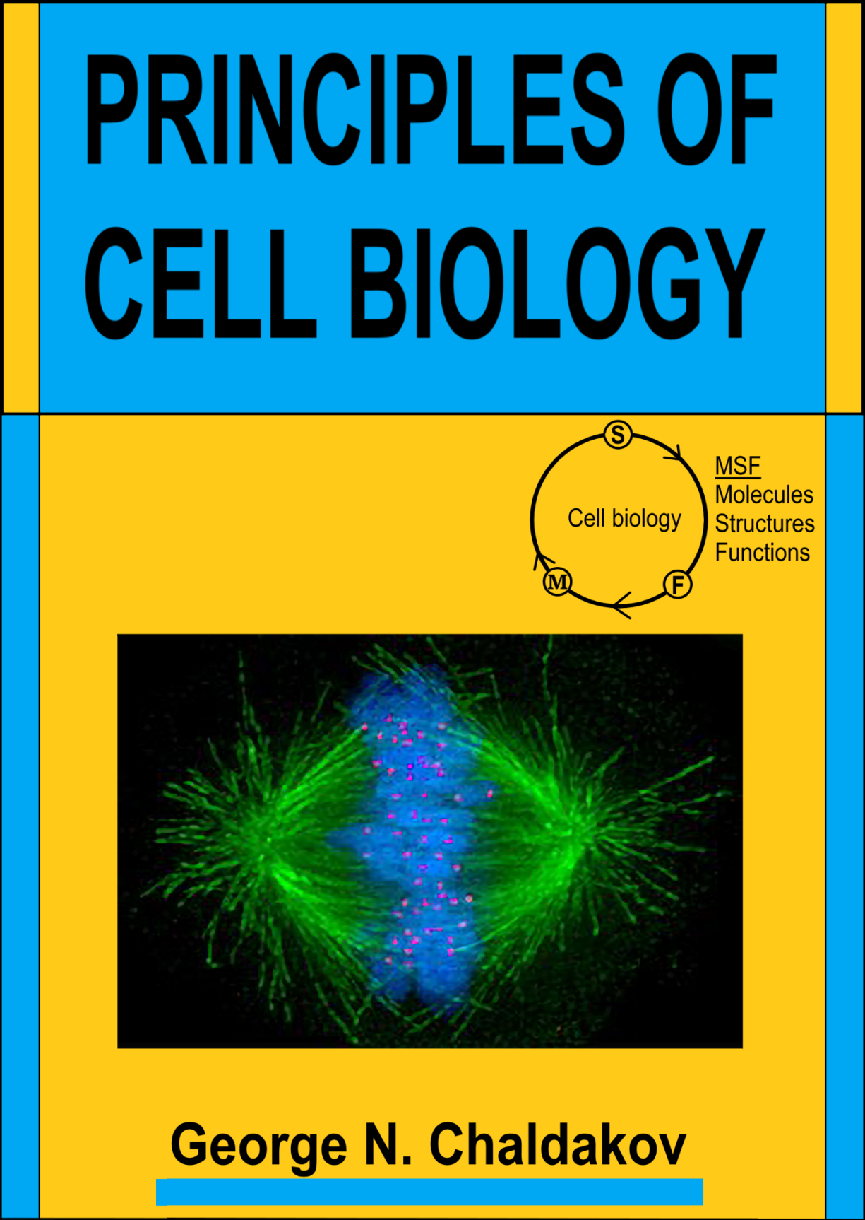
Front cover: Immunofluorescence micrograph of the mitotic spindle in a human cell showing microtubules in green, chromosomes in blue, and kinetochores in red during the metaphase of mitotic cell division. From: Wikimedia Commons.

Copyright © 2021 George Nikov Chaldakov
All rights reserved.

Учебникът е издание на BioMedES Ltd., Aberdeen, United Kingdom. www.BioMedEs.biz

Директор на изданието е професор Denys Wheatley – един от най-авторитетните клетъчни и канцер биолози в света.

PRINCIPLES OF CELL BIOLOGY , Chaldakov, George N. - Amazon.com

https://www.amazon.com/PRINCIPLES-CELL-BIOLOGY-George-Chaldakov-ebook/dp/B09QZ4DQ6F/ref=sr_1_1?crid=1BW34R81M9Y39&keywords=chaldakov&qid=1642936501&sprefix=chaldakov%2Caps%2C139&sr=8-1

Acknowledgments

Plato learned from Socrates, Aristotle – from Plato, Friedrich Nietzsche – from Fyodor M. Dostoevsky, Salvador Luria, Renato Dulbecco and Rita Levi-Montalcini – from Giuseppe Levi, Luigi Aloe – from Rita Levi-Montalcini, George Palade - from Albert Claude, Günter Blobel – from George Palade …. The author of Principles of Cell Biology – from his parents, teachers and friends.
That is a high hierarchy in action,
From the moan to the sigh - to the echo…
Hristo Fotev (1934-2002)

The textbook has grown from many years of research, reading and discussions. Among the numerous colleagues with whom I have exchanged thougths and ideas during the past 60 years, the following have been particularly influential: my scientific father Delcho Zhelyazkov, an extraordinarily knowledgeable Professor of Pharmacology. This textbook is dedicated to his memory. Also acknowledged are Krikor Dikranian and Maria Staykova for their critical reading of the manuscript, and Denys Wheatley for his editing of the manuscript, followed by its publication with the help of Angela Panther. ….………………………………………………….
Introduction The main goal of the present textbook is to provide – in a stream of associations fashion – state-of-the-science-based knowledge of cell biology and its translation into the pathogenesis, prevention and therapy of diseases, being away from any descriptive details. The major concepts of the book are (i) cell-extracellular matrix unity, (ii) triarchic (molecules, structures, and functions) core of the cell-and-matrix life, (iii) biomorphogenic principles, (iv) binary (switch on-off) nature of the cell life, and (v) general classification of cell organelles.

The author’s belief is that he educates the students by offering them a SOS-based teaching of MSF of cells and extracellular matrix (ECM) of the human body. This can enable students to understand the triarchic – MSF – nature of cell-and-matrix life. Also, the cellular and molecular mechanisms (pathogenesis) of Diseases and their Prevention and Therapy (DPT), as shown below.

Graphic abstract of the textbook
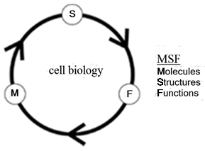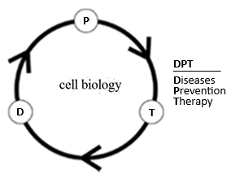

The one who sees things in growth all of them, it will have the proper understanding of them. Aristotle (384–322 BC)

The principle (Latin principium means first, foremost) on which the present textbook is based is: From MSF to DPT. Accordingly, Principles of Cell Biology is a bench-to-bedside (B2B) textbook presented in a stream of associations (SOA) fashion. Even knowing all MSF, without knowledge of the principles that govern them, we will not be able to build our own way of thinking of the astounding MSF complexity of cell biology and biomedicine in general. Of course, we should know the scientific facts, but it is my firm belief that they are required primarily to incorporate them into concepts and competencies. Facts are for today, principles and concepts are for today as well as tomorrow.
The author’s aim is to teach students in an interactive and SOA way how information becomes knowledge that would create frame of mind in biomedicine (also in human empathetic relations). Remember Chinese saying: “If you give a man a fish, you feed him for a day. If you teach him to fish, you feed him for a lifetime”; that is, “to know how”, not only “to know that”.
……..
Ultimately, I tried to write Principles of Cell Biology by presenting a novel pedagogic approach different from any traditional descriptive details. The author’s didactics is mediated by (i) SOA (Fig. 1), (ii) “A picture is worth a thousand of words”, (iii) KISS* (Keep It Short and Simple), a sort of Ockham’s razor, and (iv) Murray Gell-Mann’s plectics.
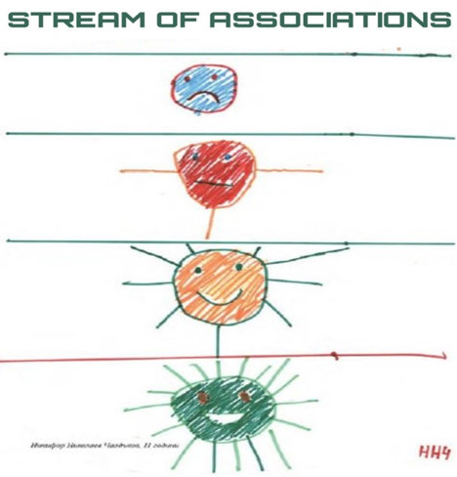
Figure 1. A drawing by my grandson Nikifor (when he was 11 year-old) presenting Stream of Associations, an emblem of the author’s didactics.

The textbook embodies a personal philosophy “standing on the shoulders of giants” in biomedical sciences. As any human activities this textbook can and should be improved. Therefore, I appeal to readers to propose corrections and enhancements.
With Respect, Love and Hope,
BHF-ly yours,
George N. Chaldakov, MD, PhD, FIACS
Correspondence to: George N. Chaldakov, MD, PhD, Department of Anatomy and Cell Biology, Medical University, BG-9002 Varna, Bulgaria
In Cell Biology language, the author’s nexuses (communicating junctions) are:
● E-mail: chaldakov@yahoo.com
● Mobile phone: +359 888 679 204
● Home phone: +359 52 754 394
● YouTube: Lectures George Chaldakov
● Scopus Elsevier, PubMed, Research Gate: George Chaldakov

Let us start then.
Principally, we shall focus on:
● Molecules that (i) make up cell and matrix Structures, and (ii) mediate cell and matricellular Functions in health and disease in multicellular organisms to which Homo sapiens belongs.
● Biomorphogenic principles (Greek, bio – life, morphe – form, genesis – origin) of the formation and dynamics of cell organelles and matrix structures. How molecules’ functions (properties) are implanted in them.
Taken together, these are summarised (Fig. 2).
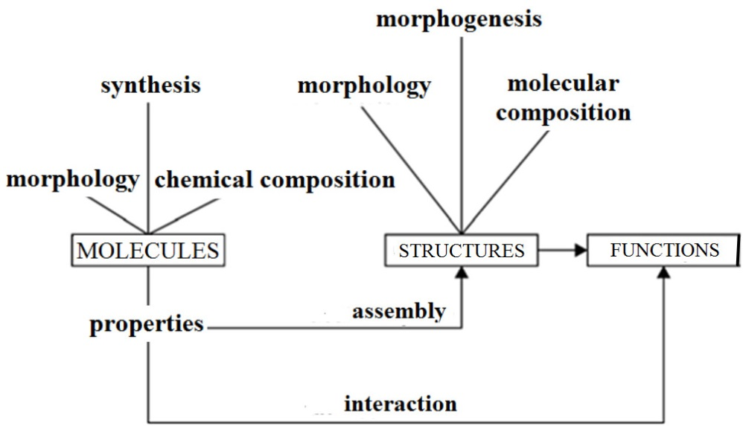

Figure 2. Students learning Cell Biology have to ask questions and give answers: Which molecules, How they act, Where they act (cell, matrix, tissue, organ), When (interphase, mitosis, meiosis), What structures they form, and What functions they perform? Hence, the more the students know cell-and-matrix MSF, the better they would understand DPT.

Hopefully, this textbook could become an essential part of Alma mater studiorum (Mother who feeds us with knowledge). The author believes that after a thoroughly reading of Principles of Cell Biology, students would better understand the currently written and spoken language of Cell Biology.
Learning objectives-1
In effect, we will reach at the following fundamental conlusions about cellular life that could be a valuable teaching resource as well as a study aid for students:
● Cells-and-matrix are indivisible units of life of all multicellular organisms. It is taken as axiomatic at the educational level that cells are “unit of life” and “building blocks of life”. However, the cells (except cells circulating in the blood, lymph, and cerebrospinal fluid) are surrounded by and linked to the matrix (ECM). When a cell is separated from the matrix, it becomes “homeless” and dies – anoikiya, a type of programmed cell death. An example of the cell-matrix unity is illustrated (Fig. 9).
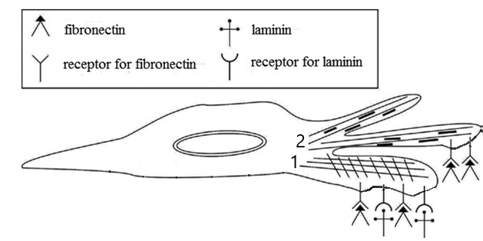
Figure 9. Schematic illustration of the unity of cell-matrix at MSF level. Depicted are lamellipodia (1) and filopodia (2) – cell’s “feet” (Greek podos), plasmalemmal projections of the leading edge of a cell, walking on matrix road via the interaction of matrix ligands (fibronectin and laminin) and plasmalemmal receptors. We may call lamellipodia and filopodia “Johnnie Walker structures”. Note, lamellipodia and filopodia are shown separately although, filopodia are, in fact, thin extensions emerging from lamellipodia. Lamellipodia and filopodia are plasmalemmal-cytoskeletal structures (fractalosomes) that play essential roles for cell mobility such as (i) axon growth and guidance seeking its synaptic contacts in the developing brain, (ii) cancer cell invasion and metastasis, and (ii) repair (closure) of skin wounds, involving keratinocytes (keratin protein-rich cells) and fibroblasts (fibers-producing cells). They move at speeds of 10–20 μm/min over the matrix route. Further studies on Mechanobiology of Cell Walk would rely on fresh thought-lines of students and young teachers.

● Biomorphogenic principles (BMP)

First BMP: Membrane compartmentalization (Figs. 10, 11).
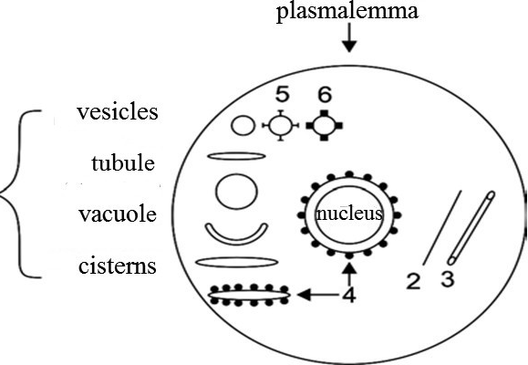

Figure 10. Schematic illustration of three levels of membrane compartmentalization: plasmalemma (arrow at the top), nucleolemma (double membrane), and endomembranes. 5. Clathrin-coated vesicles. 6. Caveolin-coated vesicle (caveolosome). The membranous structures shown at left are components of the membrane-bound organelles. Examples of nonmembrane-bound organelles: 2. Filament; 3. Microtubule; 4. Polysomes (polyribosomes) attached to the outer nuclear membrane (4) and to a cistern of rough endoplasmic reticulum (4). Note, tubule (left) is a membrane-bound, whereas microtubule (3) is a non-membrane-bound cytoskeletal structure (organelle).

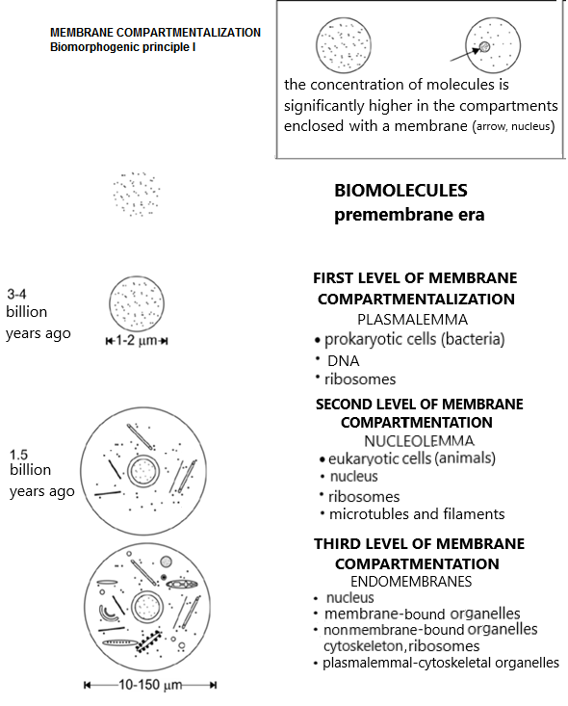
Figure 11. Membrane compartmentalization has three levels in the evolution leading to Cell sapiens and, respectively, Homo sapiens.

Second BMP: Membrane fractalization (Figs. 12-17) are examples of fractalosomes (e.g., microvilli and kinocilia) and fractal structures (glycocalyx and sarcolemmal invaginations in skeletal myocytes). Further in the text you shall learn that the fractalization BMP is also related to the morphology of endoplasmic reticulum as well as Golgi complex as shown by the original drawings of “internal reticular apparatus” by Camillo Golgi. In the same SOA: the following should be considred too – the folded nature of proteins as well as DNA (interphase chromosome) – the latter is folded into a shape termed fractal globule, as shown below:
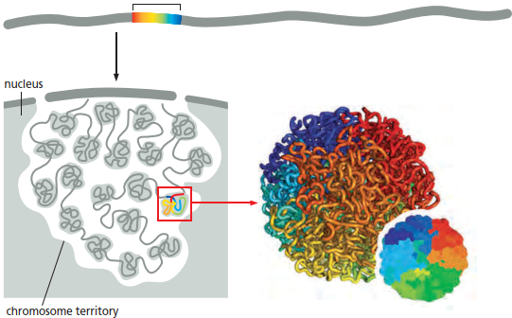

From: Alberts B, Johnson A, Lewis J, Raff M, Roberts K, Walter P. Molecular Biology of the Cell. 6th edition. 2015. Garland Science, London, New York.
……………………………………………………………….

